**How to consult timetables :**

[www.delijn.be](http://www.delijn.be)

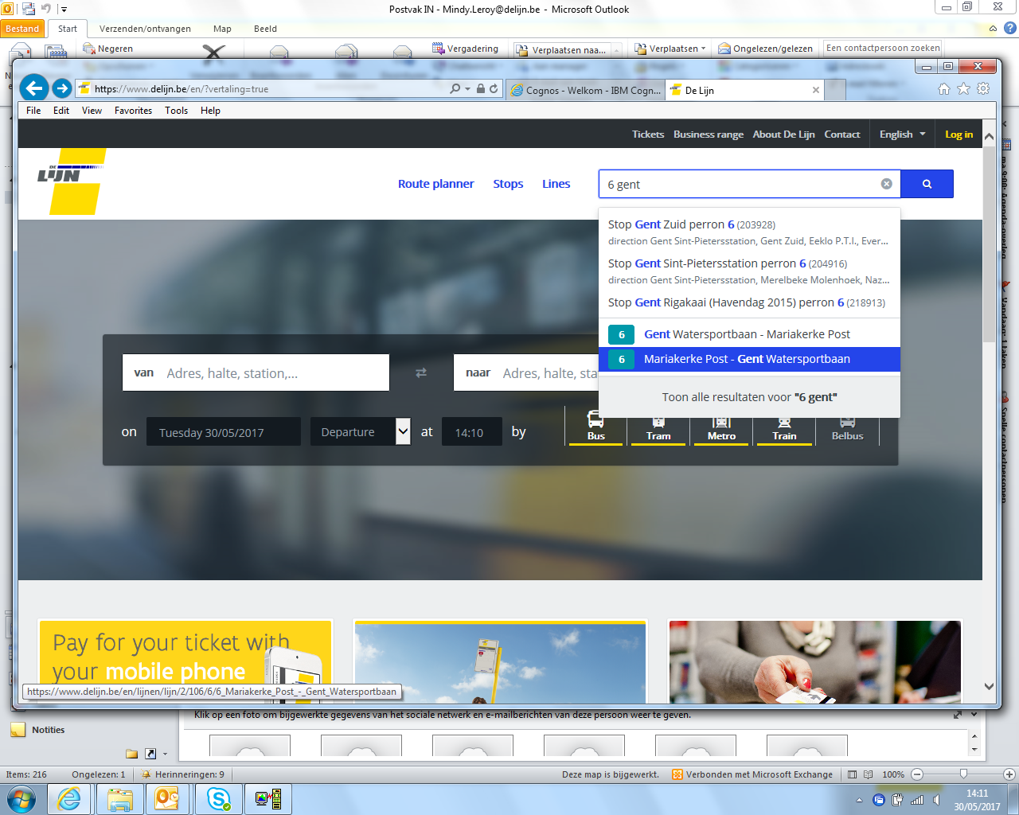

**use the search box and search by line number or name**

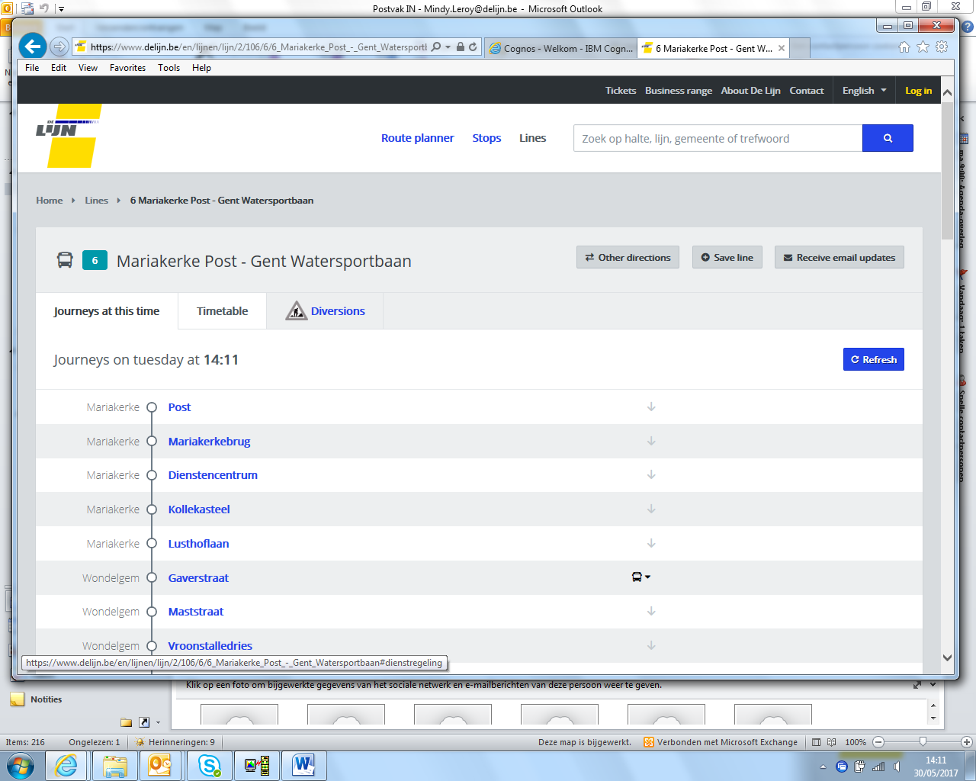

**click ‘timetable’**

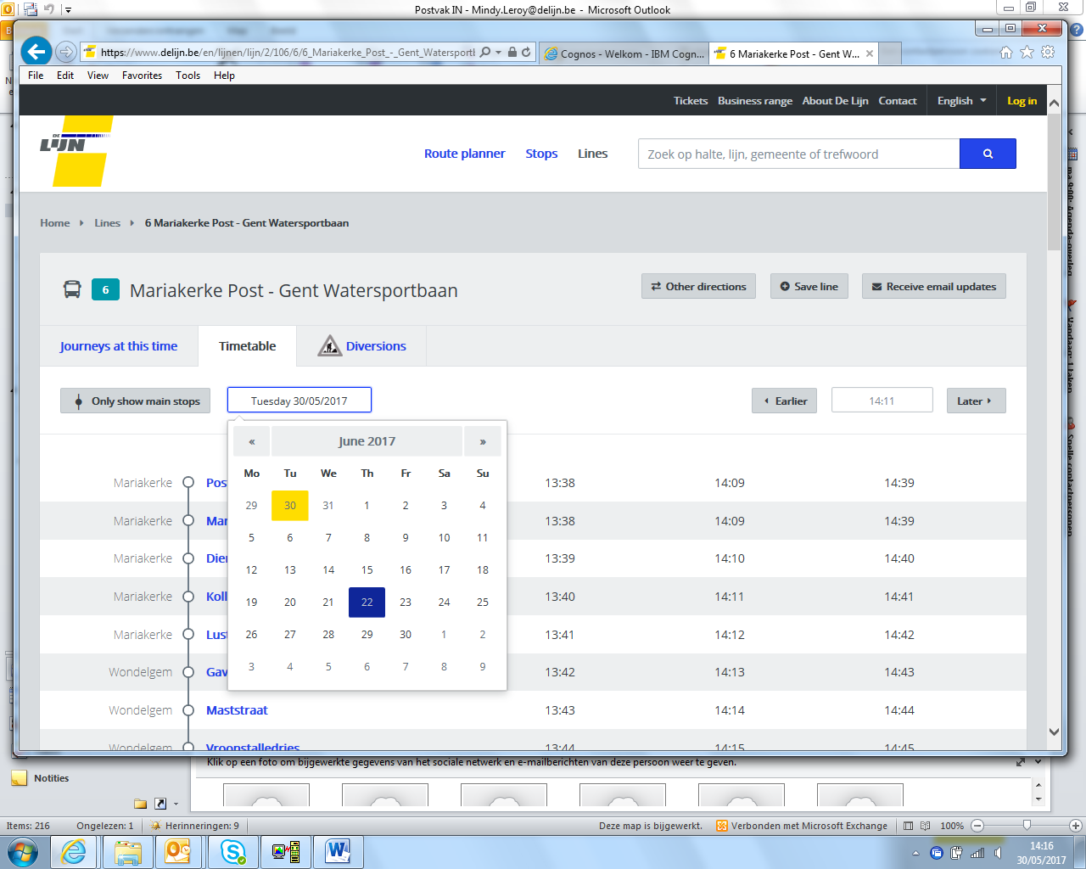

**choose date and time**



**scroll down to view the passages at your stop**

**Wrong direction?**